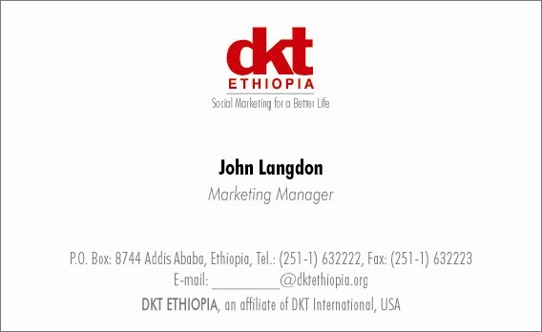

**Vacancy Announcement**

DKT Ethiopia is a social marketing organization and an affiliate of DKT International established in 1990 to promote family planning and HIV/AIDS prevention. The three main program areas are prevention of HIV/AIDS, ensuring sustainable access to family planning products and services, and improving the survival status of mothers and children.

**Please send a resume and cover letter to** [recruitment@dktethiopia.org](mailto:recruitment@dktethiopia.org)

DKT Ethiopia (Duty Station: Addis Ababa) invites potential applicants for the following post:

**Head of Marketing**

**Job Description:**

The following are job responsibility; but not limited to:

* Develop strategies and solicit approvals for all Marketing, including Digital, Advertising, Communications and Creative
* Prepare and manage allocated quarterly and annual budgets for the Marketing department
* Set, monitor and report on team goals and achievements.
* Design branding, positioning and pricing strategies in collaboration with sales and operations department.
* Ensure our brand message is strong and consistent across all channels and marketing efforts (like events, email campaigns, web pages and advertising activities)
* Analyze consumer behavior and determine customer personas.
* Identify opportunities to reach new market segments and expand market share
* Monitor competition (acquisitions, pricing changes and new products and features)
* Coordinate sales and marketing efforts to boost brand awareness
* Active participation in business planning, annual budgeting, quarterly and monthly meetings. Share feedback on competitor activity, results and challenges along with solutions during the monthly management meeting.

**Qualifications and Skills:**

* Bachelors’ or Masters’ degree in Marketing, Business Administration, Commerce etc.
* Six to eight years of product / marketing management experience.
* Product management experience in Pharma/ OTC or consumer segment.
* Sales experience in the field would be added advantage.
* An analytical mind with strong problem-solving skills.
* Negotiation skills and the ability to develop strong working relationships
* Commercial and business awareness with a Can-Do attitude
* A keen eye for detail and desire to probe further into data
* Ability to stick to time constraints and deliver on timelines
* Strong interpersonal and communication skills.
* Excellent written and verbal English proficiency.
* Proficient in MS Office
* Minimum 15% time spent evaluating competition and marketing strategy implementation in the sales field / market.

Reports to: Country Director