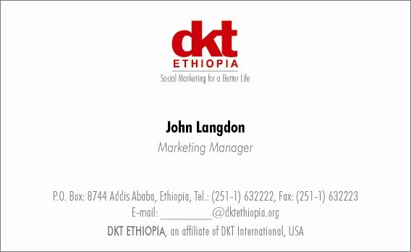

**Vacancy Announcement**

DKT Ethiopia is a social marketing organization and an affiliate of DKT International, established in 1990 to promote family planning and HIV/AIDS prevention. The three main program areas are prevention of HIV/AIDS, ensuring sustainable access to family planning products and services, and improving the survival status of mothers and children.

**Please send a resume and cover letter to** [recruitment@dktethiopia.org](mailto:recruitment@dktethiopia.org)

DKT Ethiopia (Duty Station: Addis Ababa) invites potential applicants for the following post:

**Head of Programs:**

**Job Description:**

The following are job responsibility; but not limited to:

* SRH strategy execution and program implementation
* Measurement, analytics, reporting and communicating results.
* Program performance management.
* Grant ownership and project administration
* Develop close relationship with Government ministries, institutions and other implementing partners
* Adapting business practices into program management. Active involvement in business strategy for DKT Ethiopia.

**Qualifications and Skills:**

* Bachelors’ or Masters’ degree in Project Management, Business Administration, Public Health, Social Sciences, Engineering etc.
* Minimum 6 years of relevant experience in the development sector with exposure to grant management and M&E. A social entrepreneurial mindset that drives the program is necessary. Demonstrated program innovations exposure is highly desirable.
* Commercial and business awareness.
* An analytical mind with strong problem-solving skills.
* Negotiation skills and the ability to develop strong working relationships
* A keen eye for detail and desire to probe further into data
* Ability to stick to time constraints and deliver on timelines
* Strong interpersonal and communication skills.
* Project proposal, research and technical writing expertise is preferable.
* Ability to cope with stressful situations and manage within limited resources.
* Excellent written and verbal English proficiency
* Proficient in MS Office

Reports to: Country Director