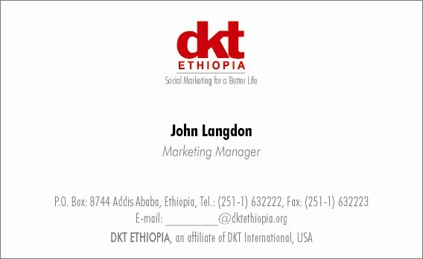

**Vacancy Announcement**

DKT Ethiopia is a social marketing organization and an affiliate of DKT International established in 1990 to promote family planning and HIV/AIDS prevention. The three main program areas are prevention of HIV/AIDS, ensuring sustainable access to family planning products and services, and improving the survival status of mothers and children.

**Please send a resume and cover letter to** [recruitment@dktethiopia.org](mailto:recruitment@dktethiopia.org)

DKT Ethiopia (Duty Station: Addis Ababa) invites potential applicants for the following post:

**Head of Sales**

**Job Description:**

The following are job responsibility; but not limited to:

* Develop and implement comprehensive sales plans to achieve growth objectives, including lead generation and revenue targets.
* Collaborate with cross-functional teams to ensure that sales and marketing efforts are aligned with product development and delivery.
* Allocation of sales force efforts to optimize portfolio results and establishing required sales KPI to empower the sales force.
* Improving coaching skills, product knowledge and selling skills of the sales team.
* Development and approval of work plans to ensure optimized use of resources both man power and infrastructure.
* Accountable for increasing penetration and expanding direct geographic cover of pharmacies and clinic network.
* Be able to represent the company at relevant forums including federal government department, local government offices and other partner forums.
* Demonstrated experience in distribution network development, managing channels, route to market etc.
* Establish, monitor and analyze sales metrics to optimize performance and identify
* Timely launch of new products, implementation of product positioning and delivery of desired results.
* Active participation in business planning and monthly feedback on competitor activity, results and challenges along with solutions.

**Qualifications and Skills:**

* Bachelors’ or Masters’ degree in Marketing, Business Administration, Commerce etc.
* Six to eight years of senior sales management experience.
* New product launch experience in Pharma/ OTC or consumer
* An analytical mind with strong problem-solving skills.
* Negotiation skills and the ability to develop strong working relationships
* Commercial and business awareness with a Can-Do attitude
* A keen eye for detail and desire to probe further into data
* Ability to stick to time constraints and deliver on timelines
* Strong interpersonal and communication skills.
* Excellent written and verbal English proficiency.
* Proficient in MS Office
* Minimum 30% time spent coaching and working in the sales field / market.

Reports to: Country Director